# Status Report # 2

Report Date

January 29, 2016

Progress Overview

During this period we were successfully able to complete the System Analysis and Design document. The completion of this document is a significant milestone in the overall completion of our final project as it allows us a reference and base for the rest of the project.

During this period we also were able to get a project started with Spring that when done will be the file upload API. Currently the API though basic, allows getting details about a user and adding a new user to the database (registering).

Budget Overview

## Cost Overview as of January 29, 2016

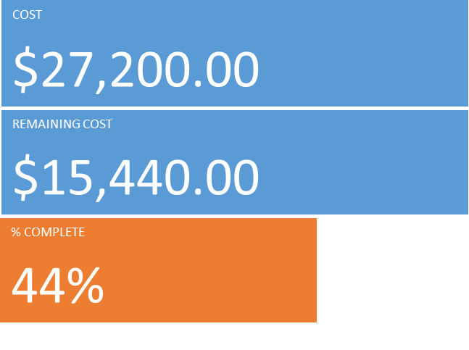

## Cost Status for all top-level tasks

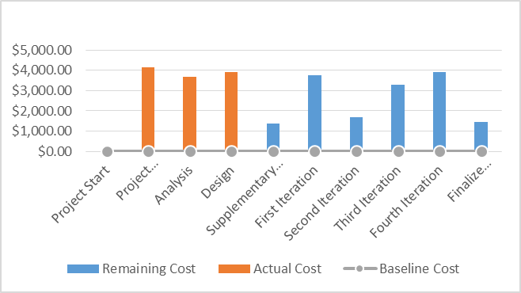

## Cost Status breakdown for all top-level tasks

|  |  |  |  |  |  |
| --- | --- | --- | --- | --- | --- |
| **Name** | **Actual Cost** | **Remaining Cost** | **Baseline Cost** | **Cost** | **Cost Variance** |
| Project Start | $0.00 | $0.00 | $0.00 | $0.00 | $0.00 |
| Project Management | $4,160.00 | $0.00 | $0.00 | $4,160.00 | $4,160.00 |
| Analysis | $3,680.00 | $0.00 | $0.00 | $3,680.00 | $3,680.00 |
| Design | $3,920.00 | $0.00 | $0.00 | $3,920.00 | $3,920.00 |
| Supplementary Requirements | $0.00 | $1,360.00 | $0.00 | $1,360.00 | $1,360.00 |
| First Iteration | $0.00 | $3,760.00 | $0.00 | $3,760.00 | $3,760.00 |
| Second Iteration | $0.00 | $1,680.00 | $0.00 | $1,680.00 | $1,680.00 |
| Third Iteration | $0.00 | $3,280.00 | $0.00 | $3,280.00 | $3,280.00 |
| Fourth Iteration | $0.00 | $3,920.00 | $0.00 | $3,920.00 | $3,920.00 |
| Finalize Application | $0.00 | $1,440.00 | $0.00 | $1,440.00 | $1,440.00 |

Outstanding Issues/Purposed Solutions

There are no current outstanding issues.

Change Requests

There are currently no pending or active change requests.

Plans For Next Period

During the next period we will be focusing primarily on the programing side of the project. We already have the fundamentals of what we’re going to user set up (Git, IDEs, etc.) so we should be able to get to work immediately.

Our goals during the next period are to get the majority of the file upload API working, which the exception of the actual uploading of files. By getting everything else working we’ll still be able to work on client side programming. The main reason for taking a longer time with the file upload part of the API is to ensure that we have time to research and do it correctly, as it’s the main part of the system we’re not yet sure how to implement.